1. Launch one ec2 using Amazon Linux 2 image and add script in user data to install Apache.

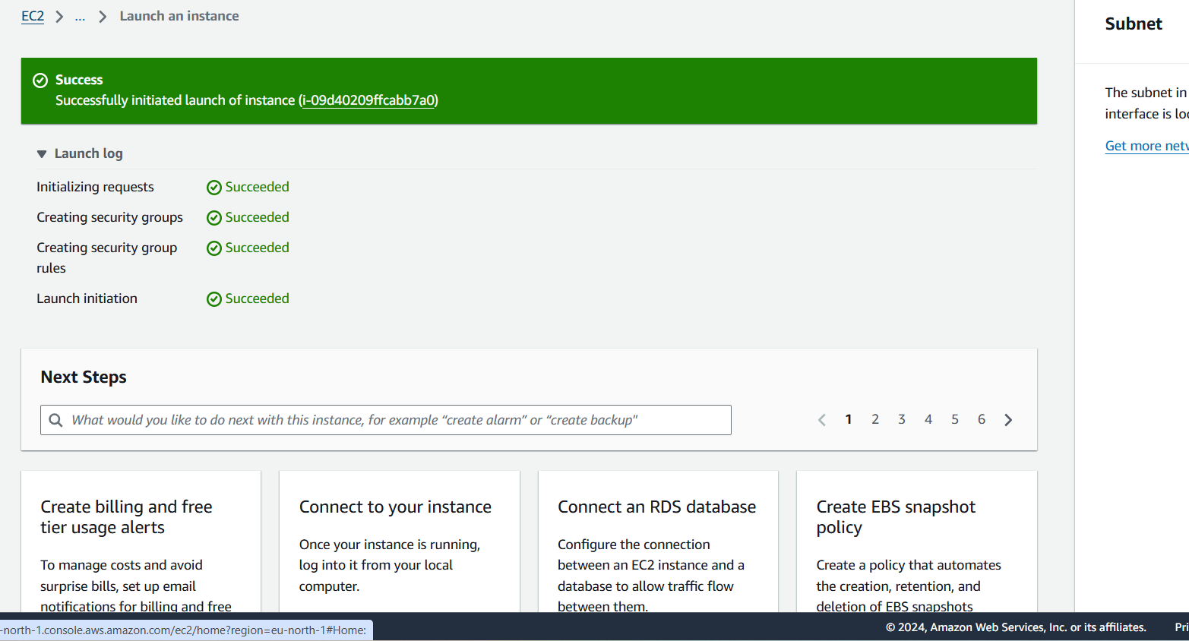

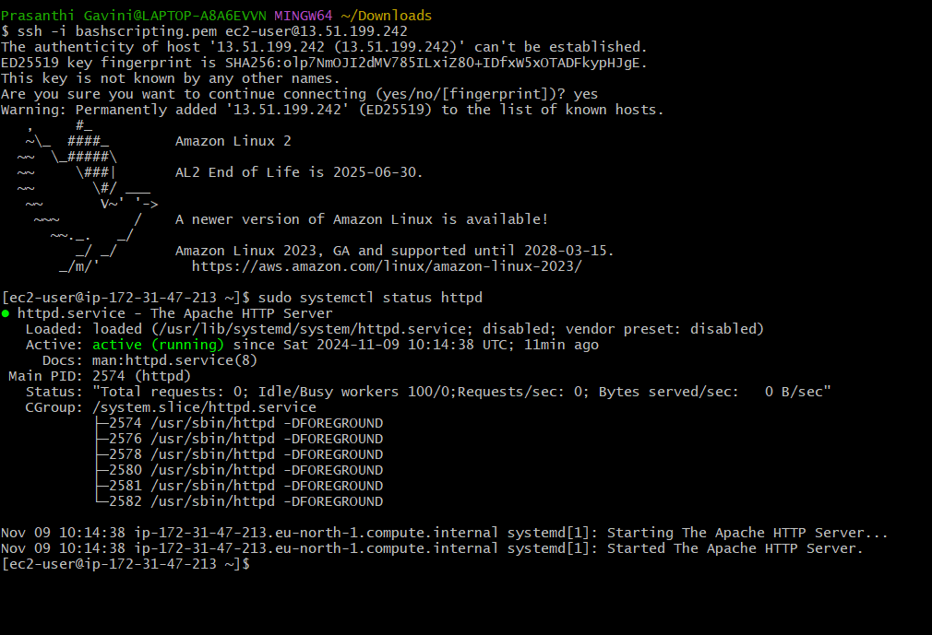

1. Launch one ec2 using Ubuntu image and add script in user data to install Nginx.

#!/bin/bash

sudo apt update

sudo apt install -y nginx

echo “installed nginx using userdata” >> /usr/share/nginx/html/index.html

sudo systemctl start nginx

sudo systemctl enable nginx

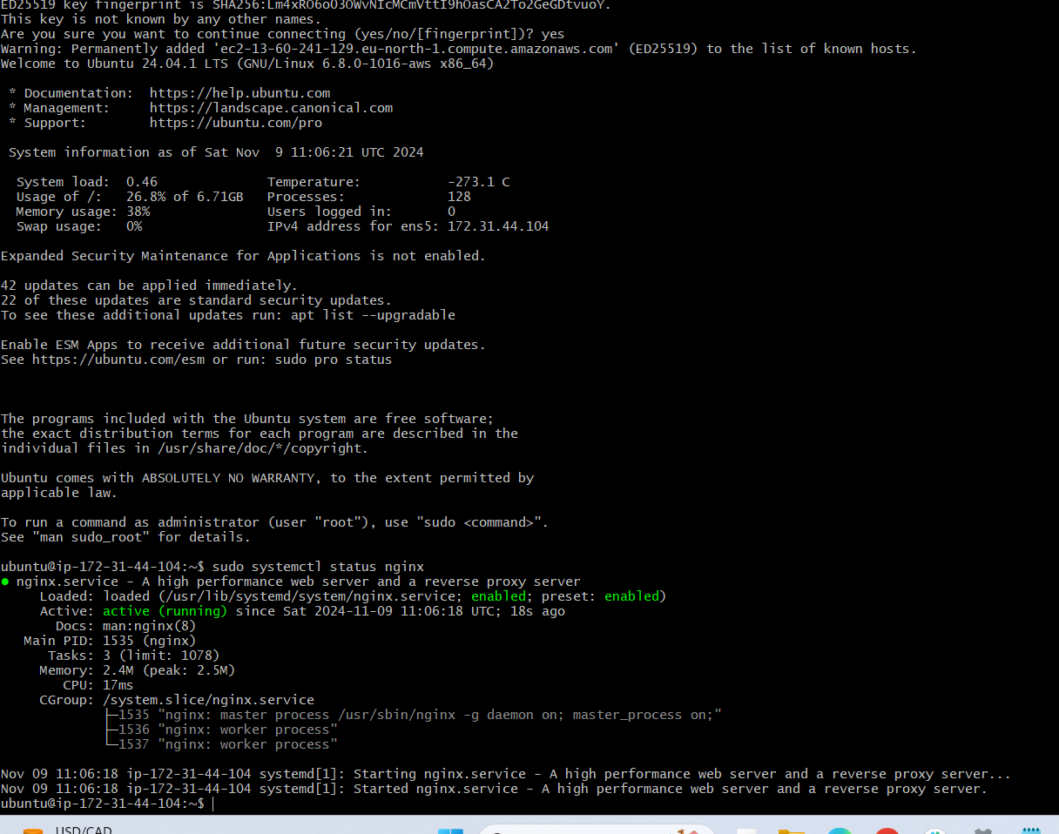

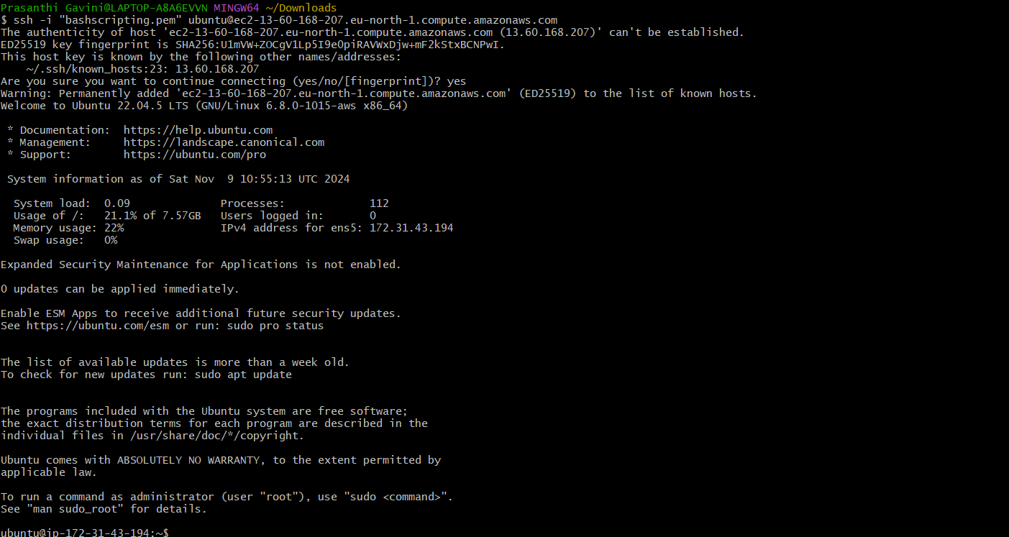

Assign password less authentication for ec2 created on Task 2.

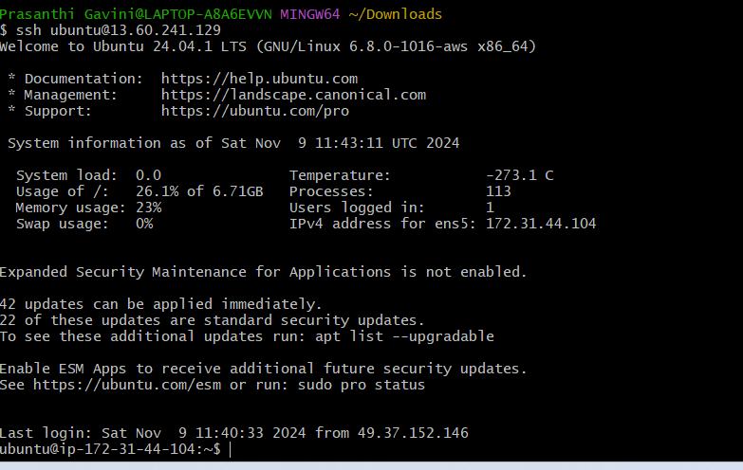

1. Take snapshot of the instane created in Task 1



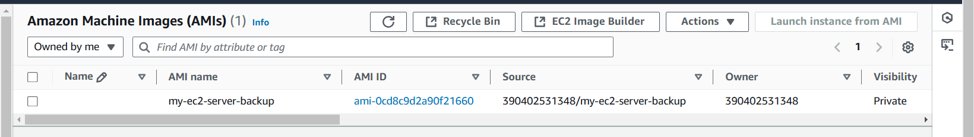

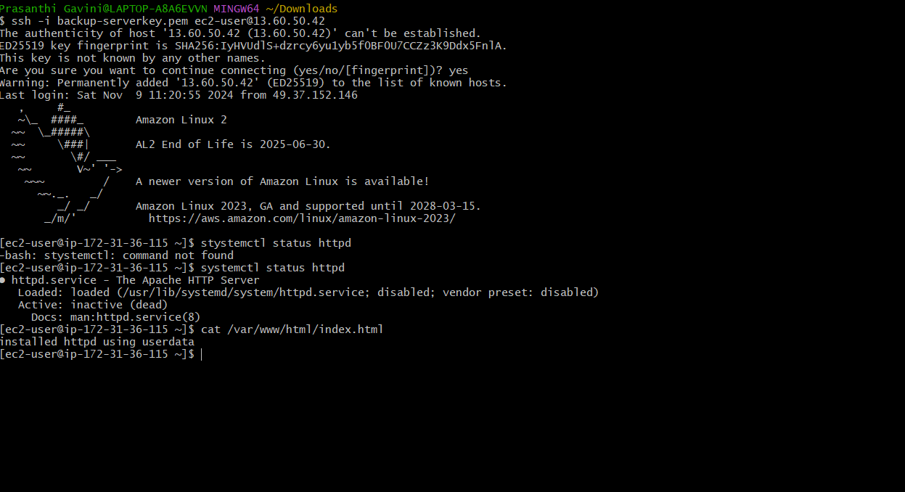

Launch one ec2 using Aws CLI